1. Go to office.com

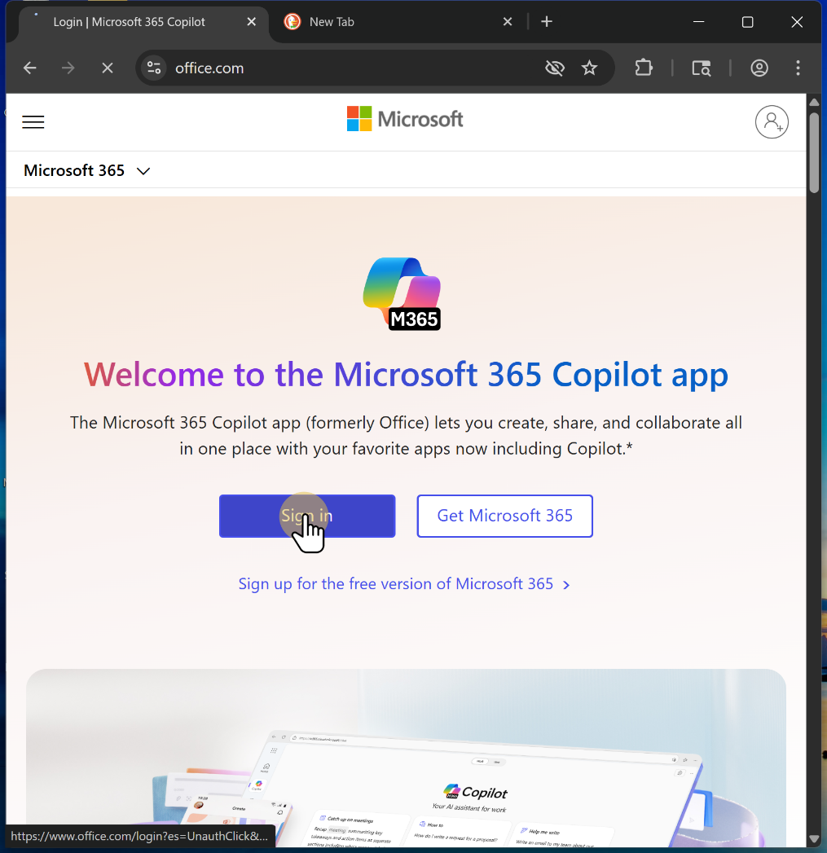

1.1. Sign in with your StarId email ending in go.minnstate.edu

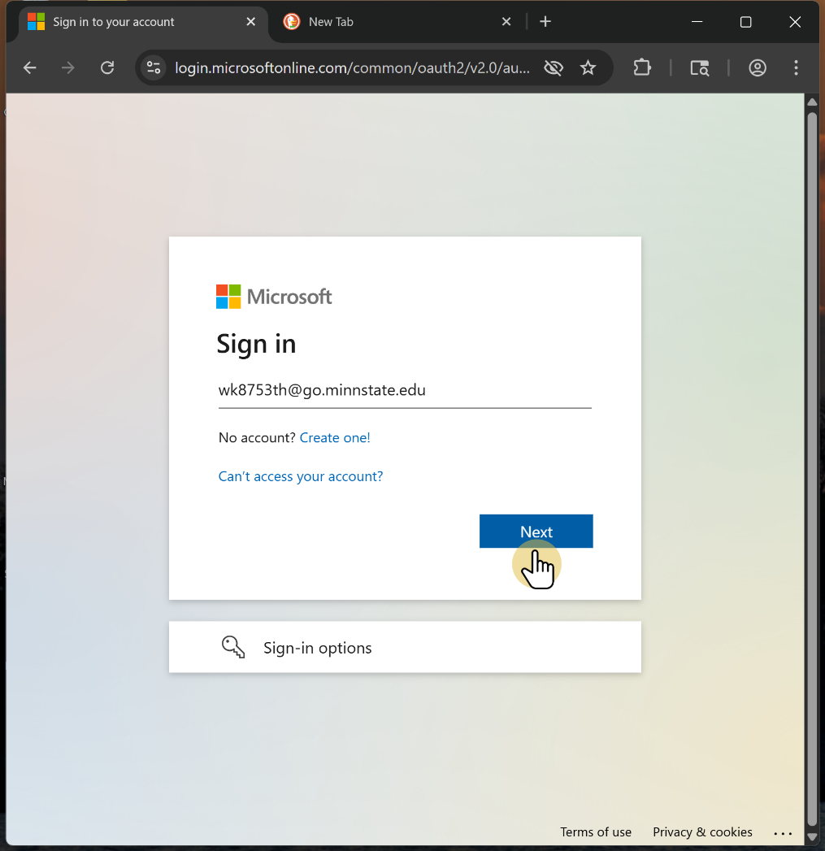

1.2. Enter your password.

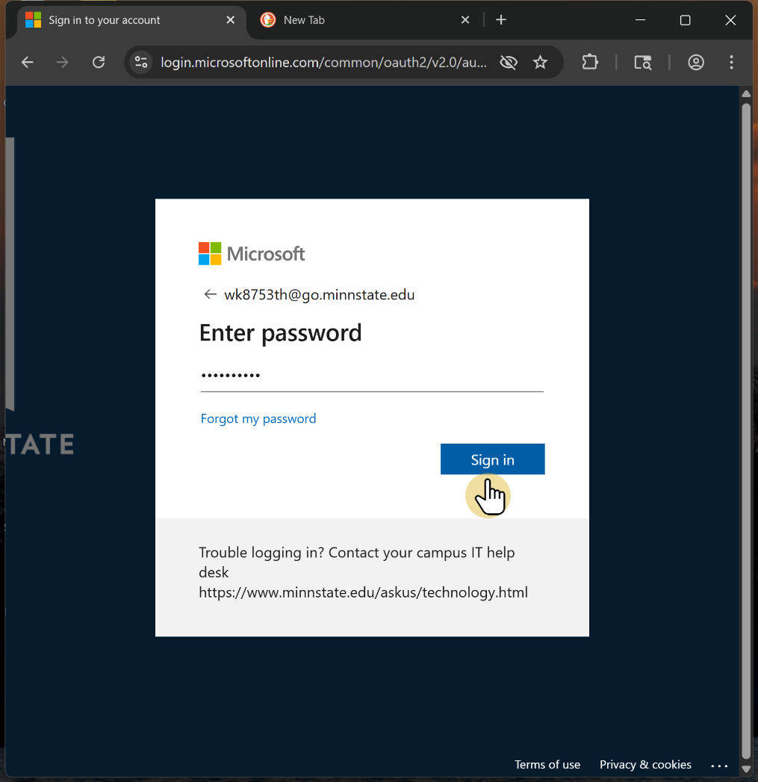

1.3. Enter your authentication code

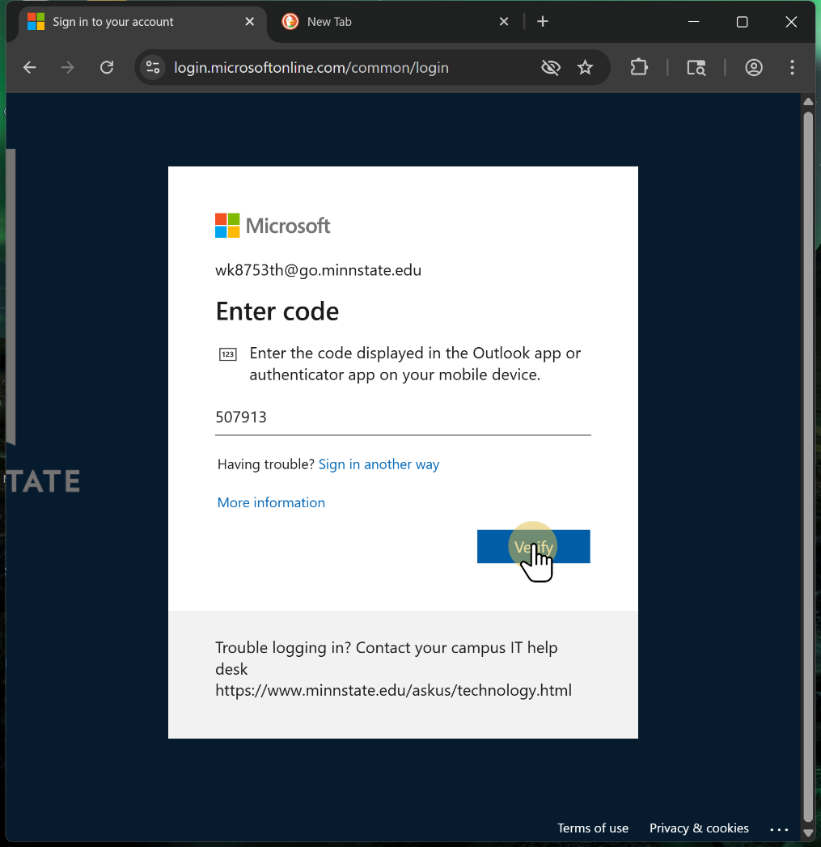

1.4. Click "No" unless you are on your private computer.

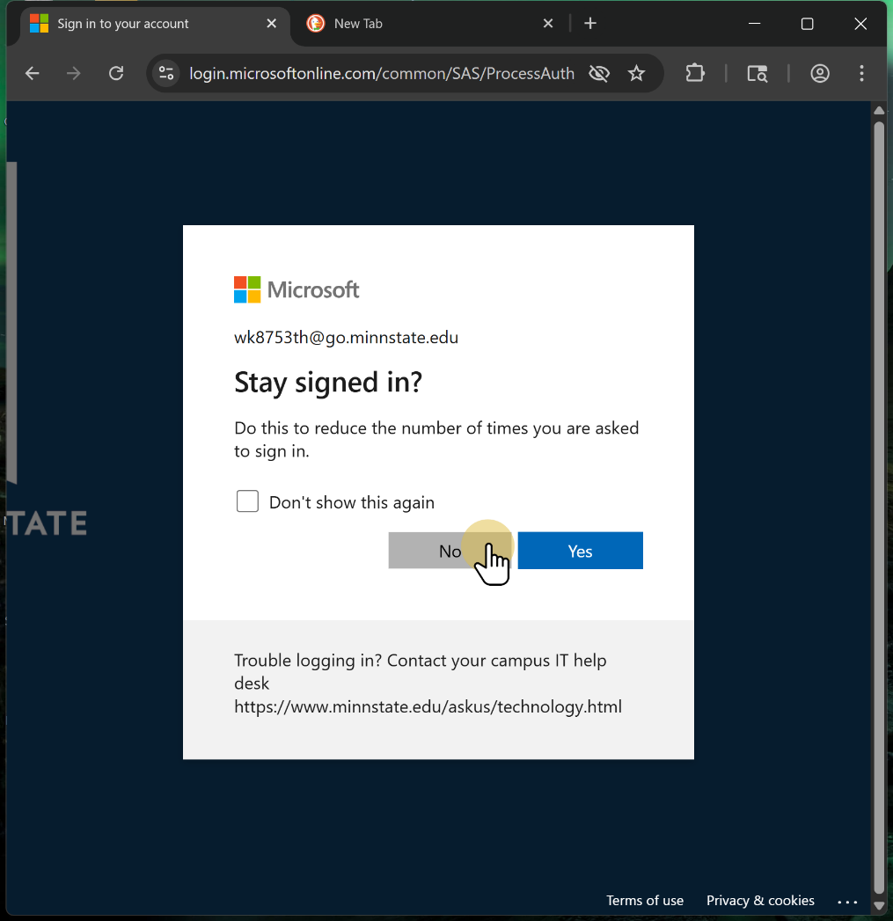

1.5. Ignore this nonsense. Go to the upper left corner.

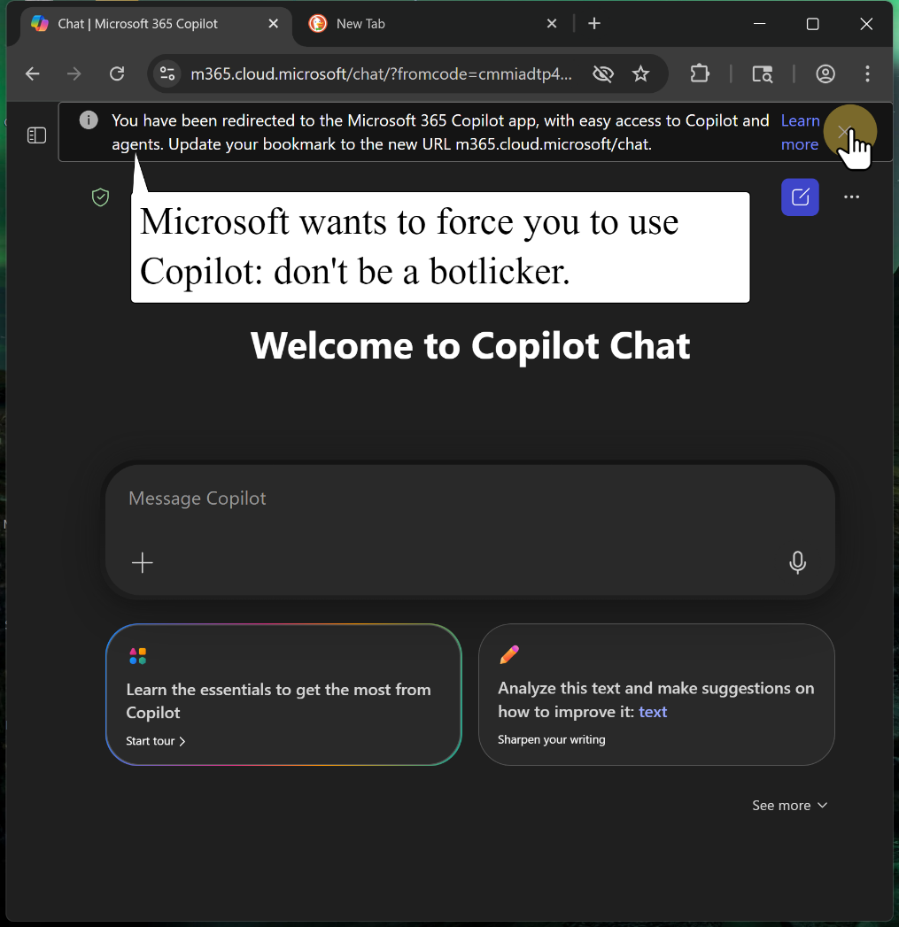

1.6. Select this icon, or the word "apps" if it appears.

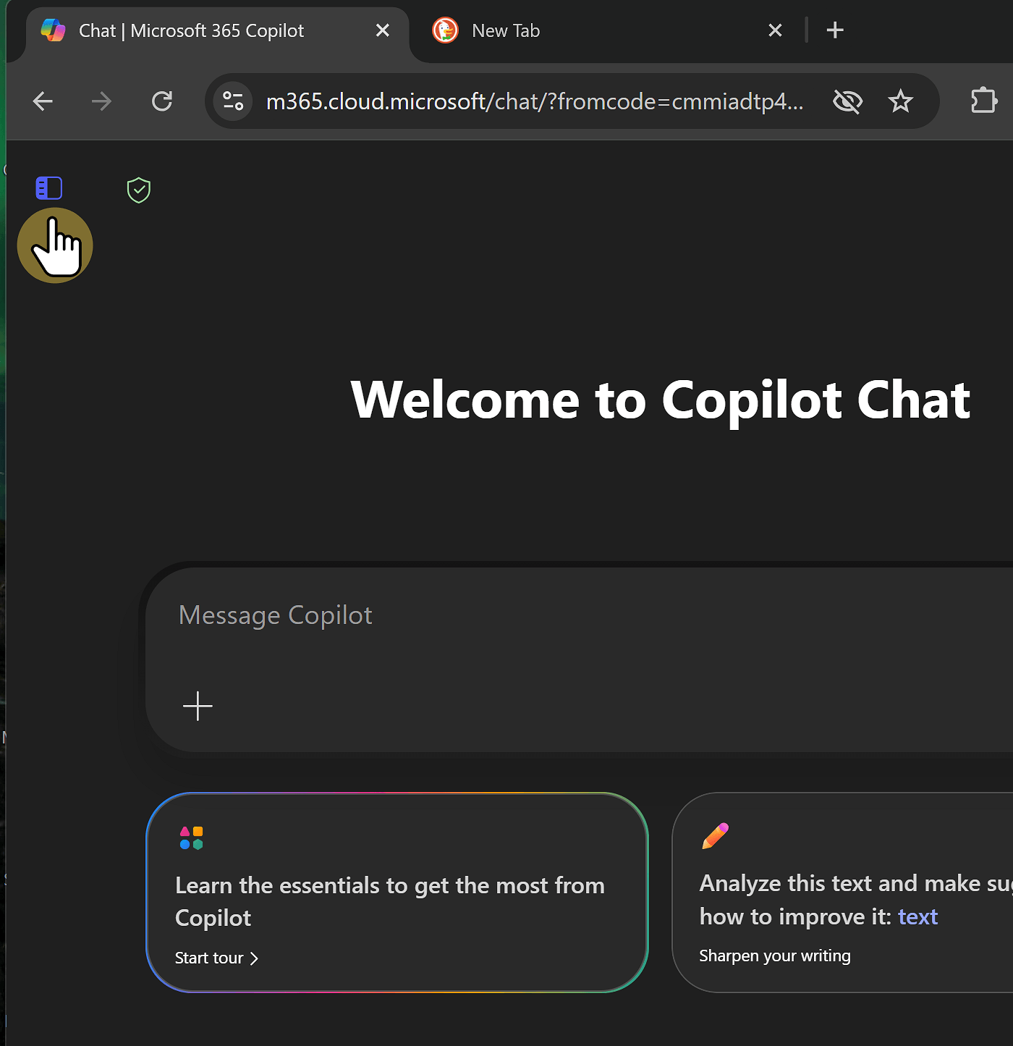

2. Select "OneDrive"
OneDrive is your Minnstate cloud drive. All your work in Word online will automatically save to OneDrive.

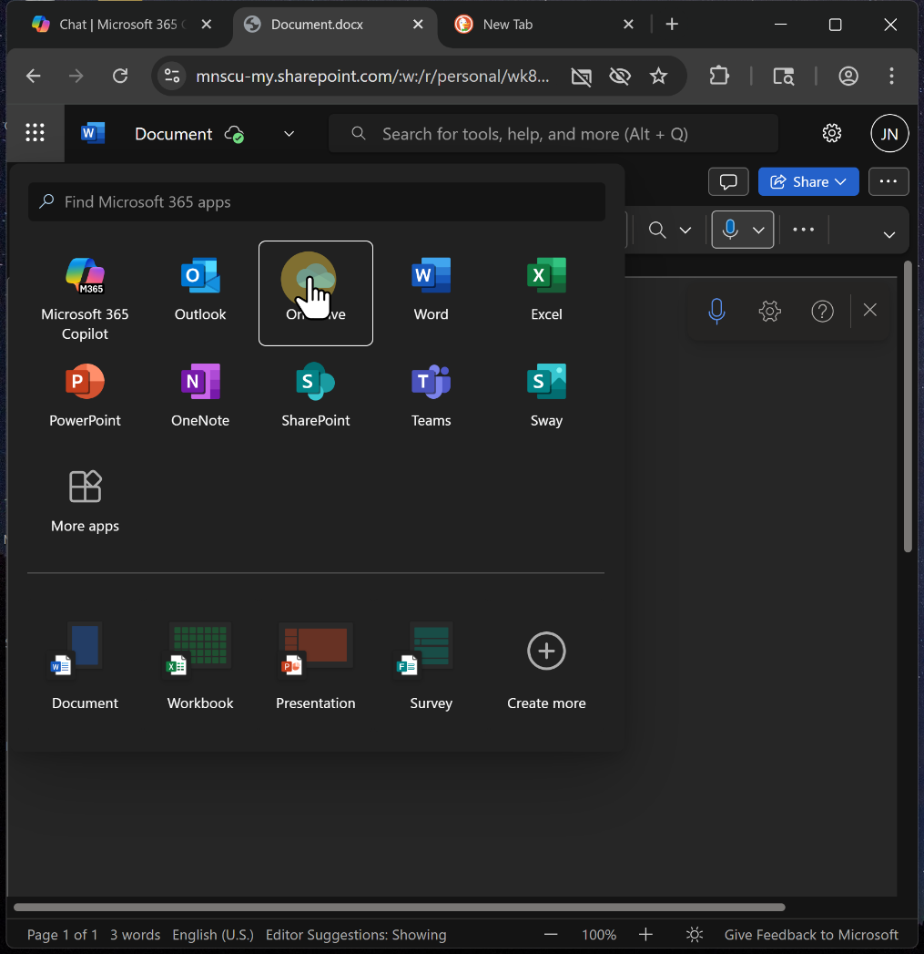

2.1. Select the "folder" icon.

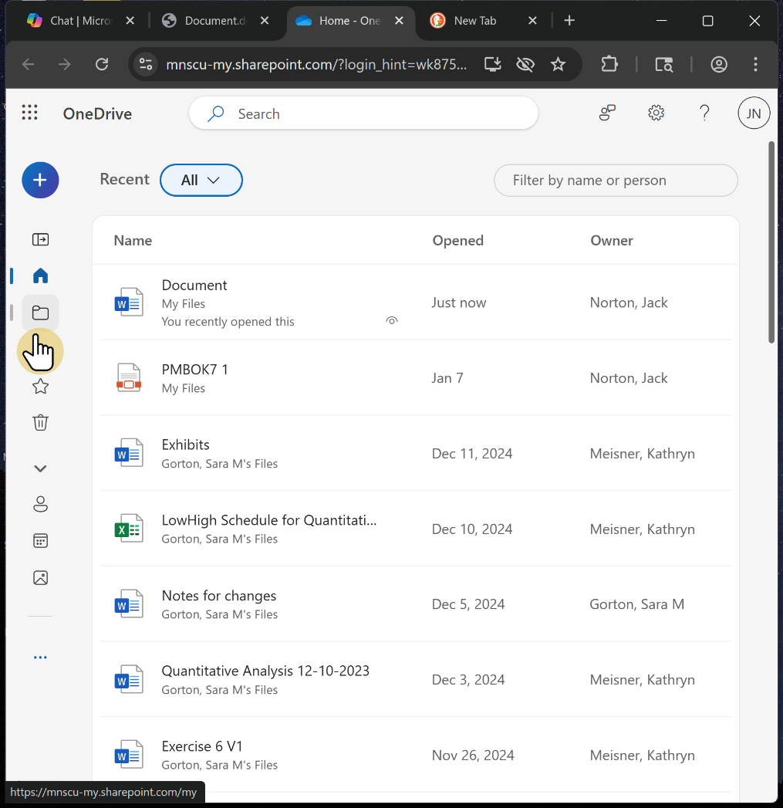

2.2. Sign in again, if necessary.
Thanks Microsoft.

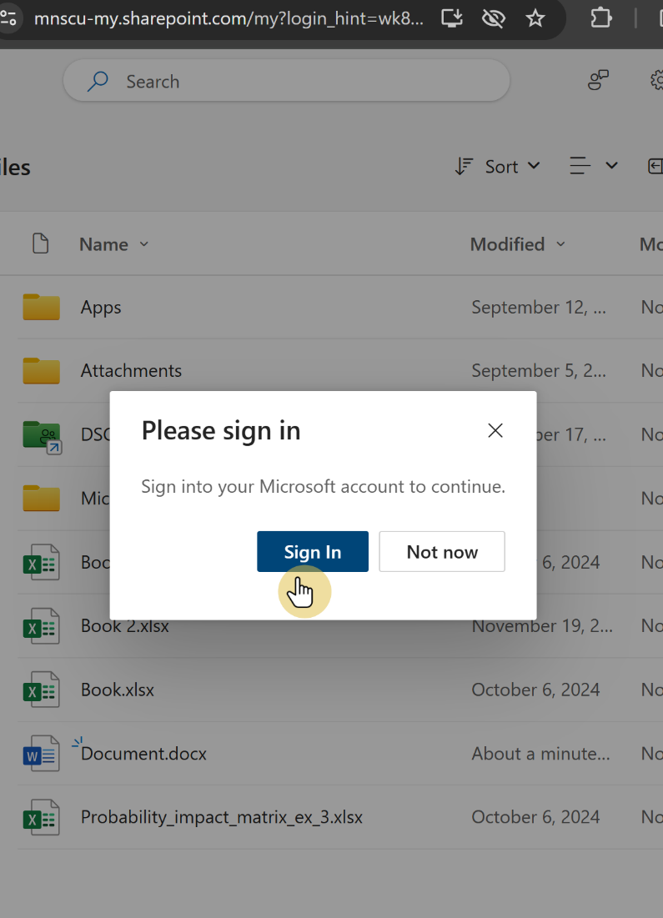

2.3. Click the "+" icon.

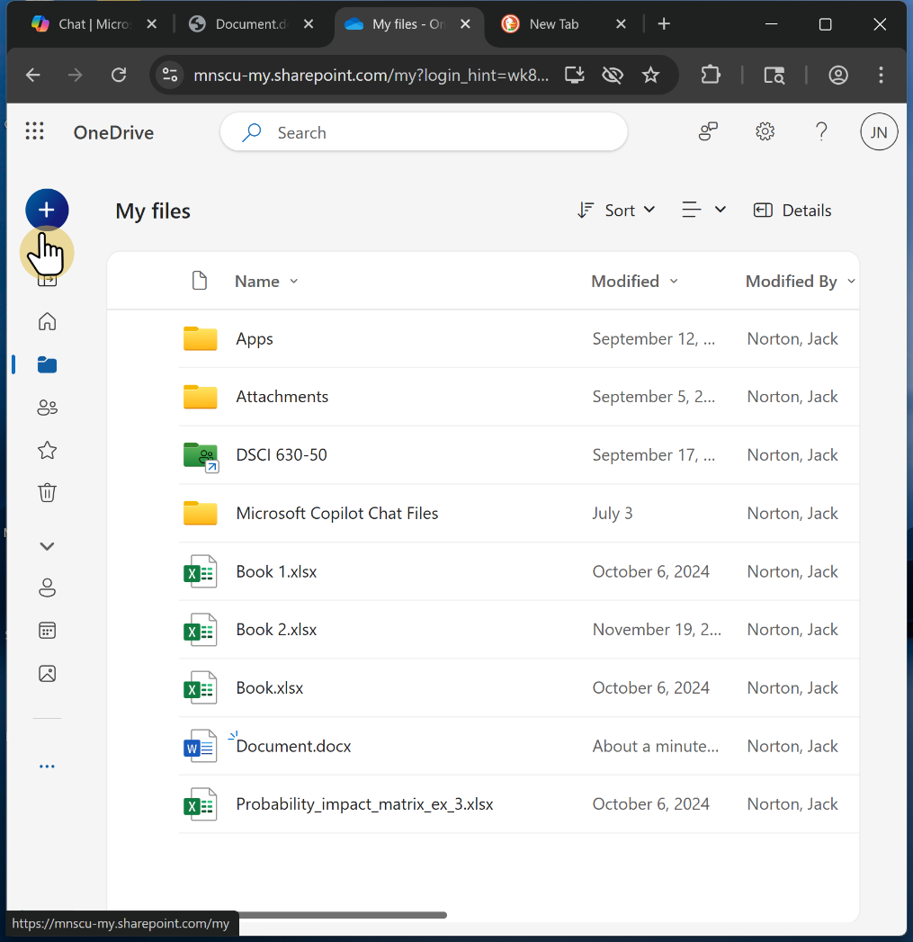

2.4. Select the folder icon in yellow.

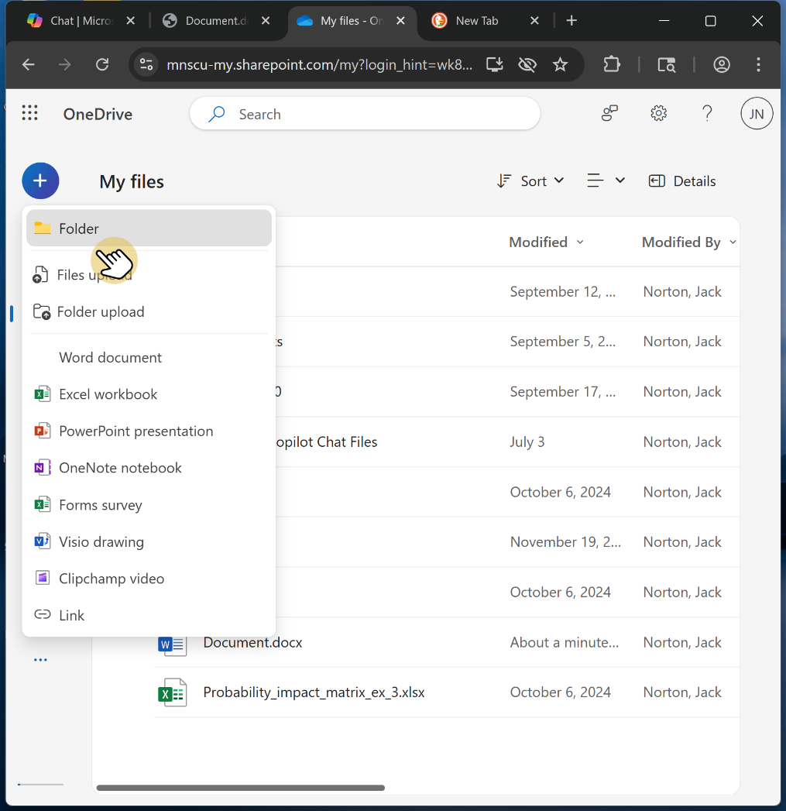

2.5. Name your folder with your last name and "History Assignment FOLDER"
Chose any color you like: that's a you thing :)

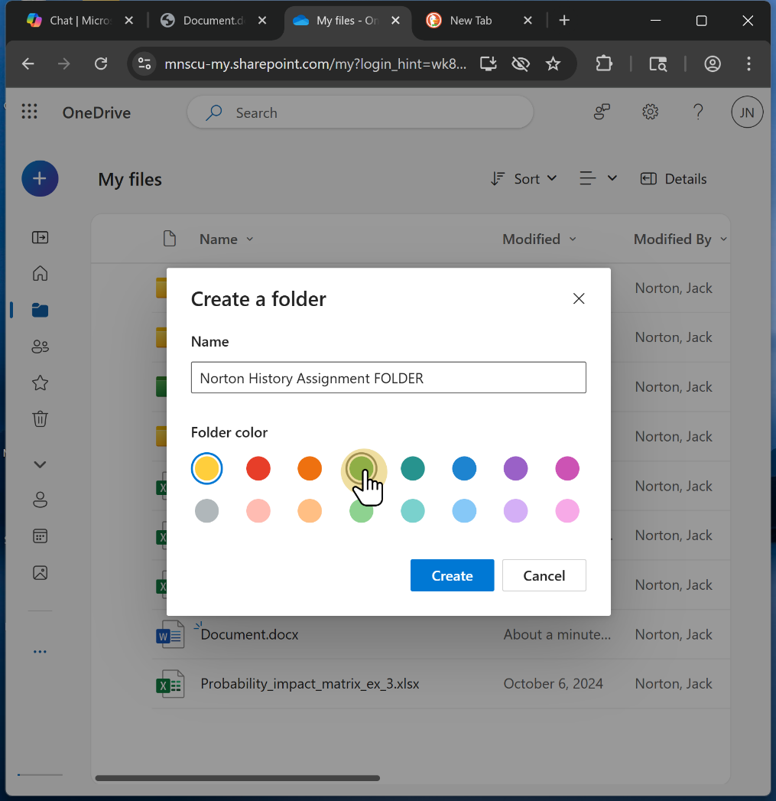

2.6. Select "Create"

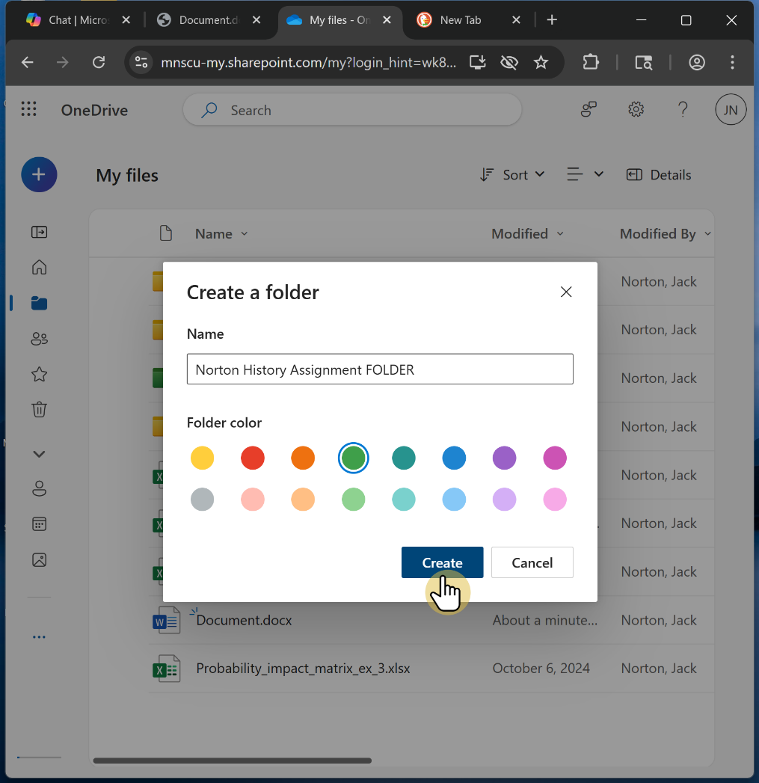

2.7. Once your folder is created, select the three dots to the right of the name.

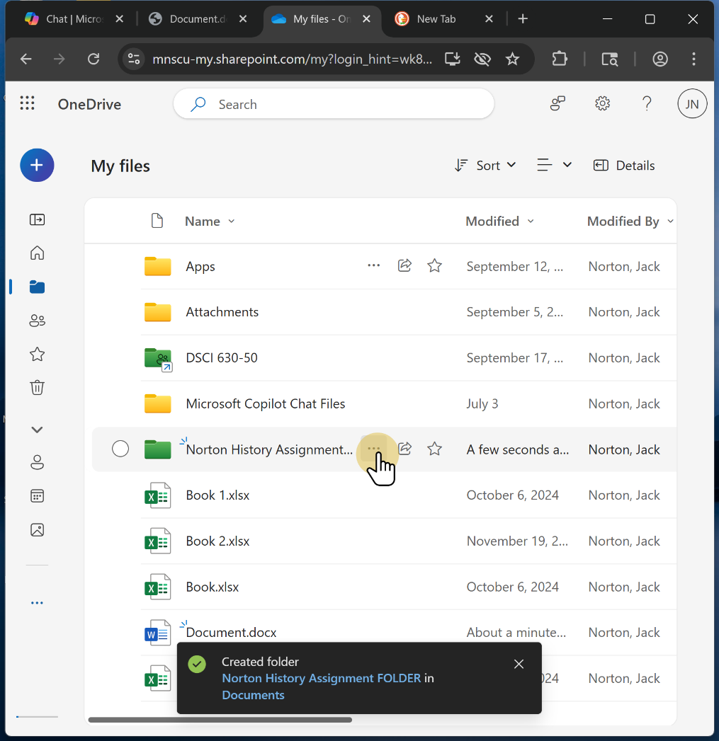

2.8. Click on "Share"

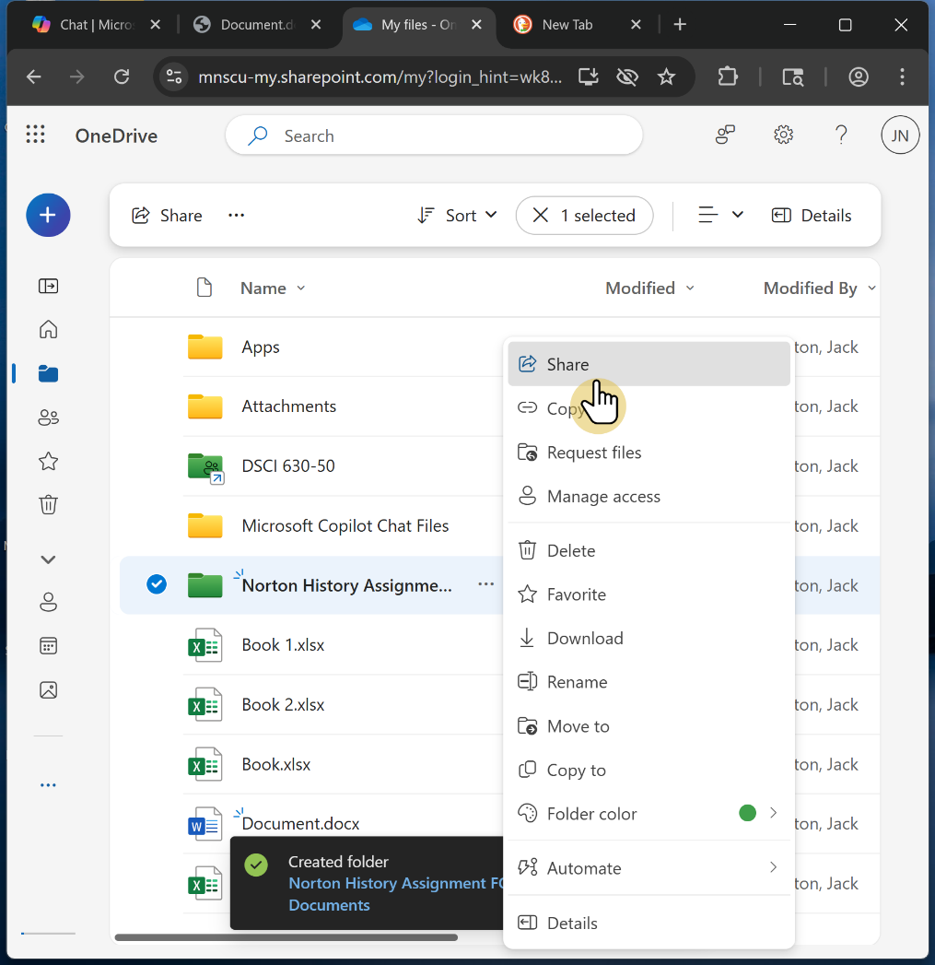

2.9. add "jack.norton@normandale.edu" to this box.

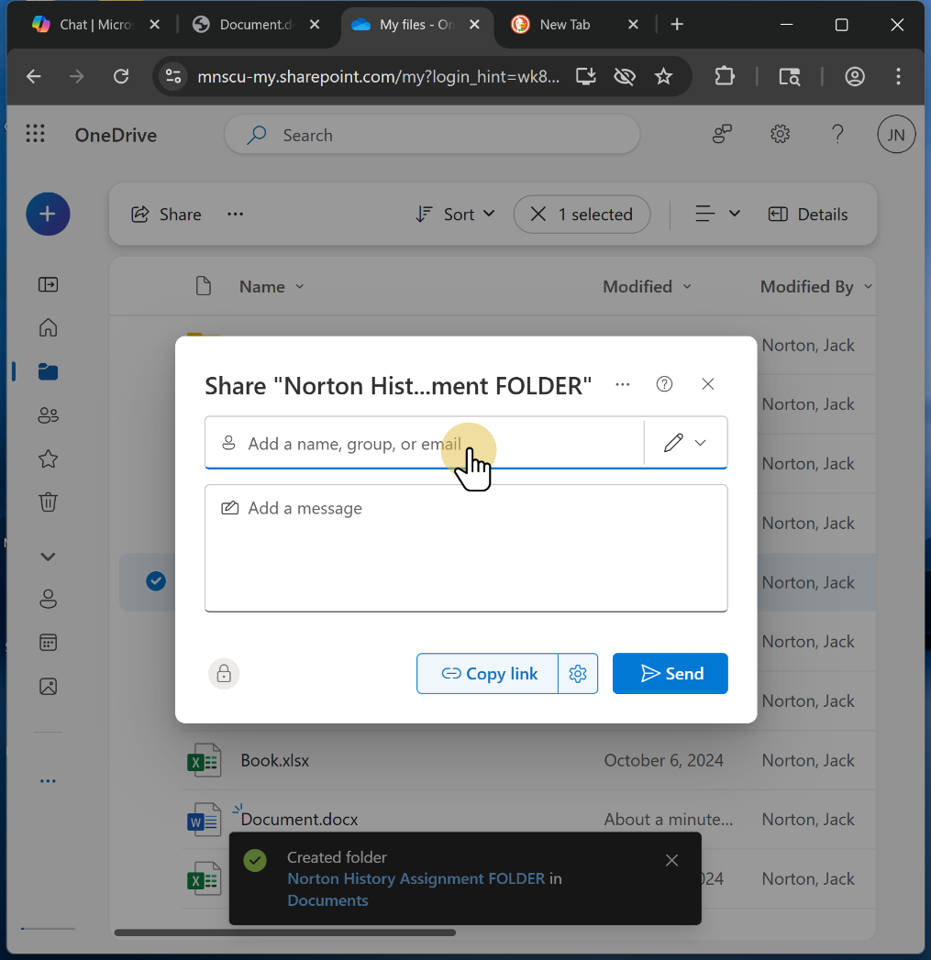

2.10. My name will appear and face will appear.

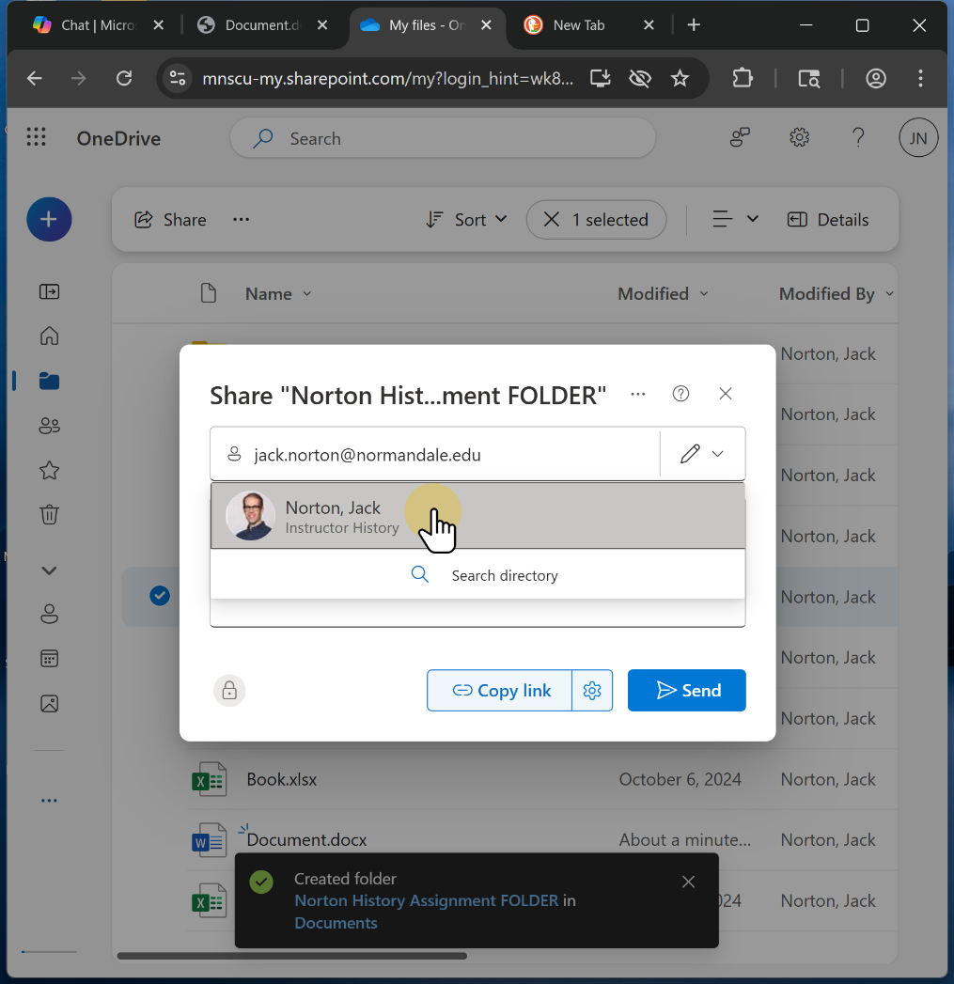

2.11. Copy the link BEFORE you share.

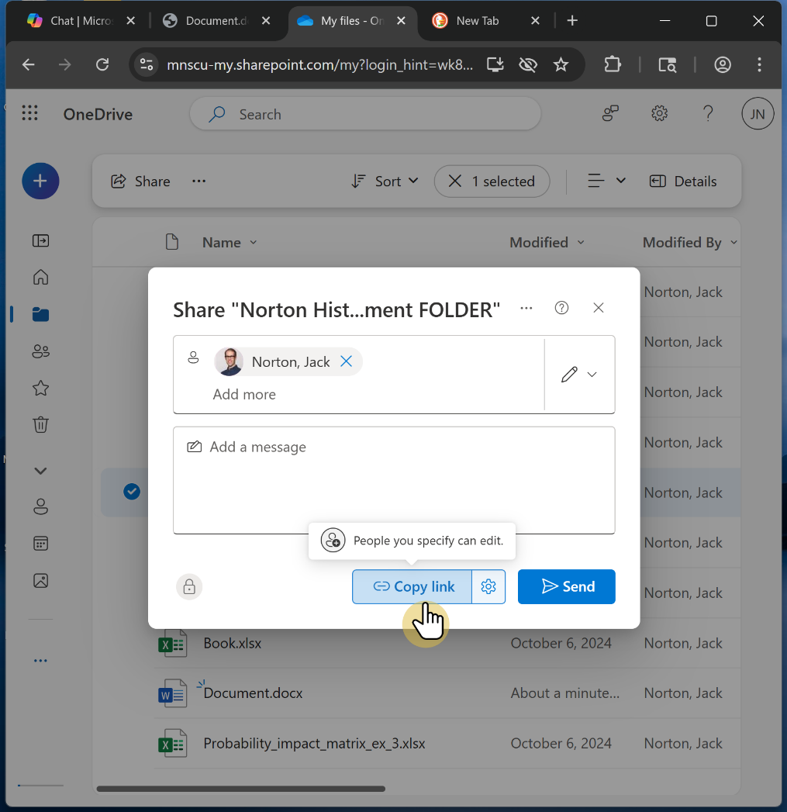

2.12. Send the message.
Feel free to add a message if you wish.

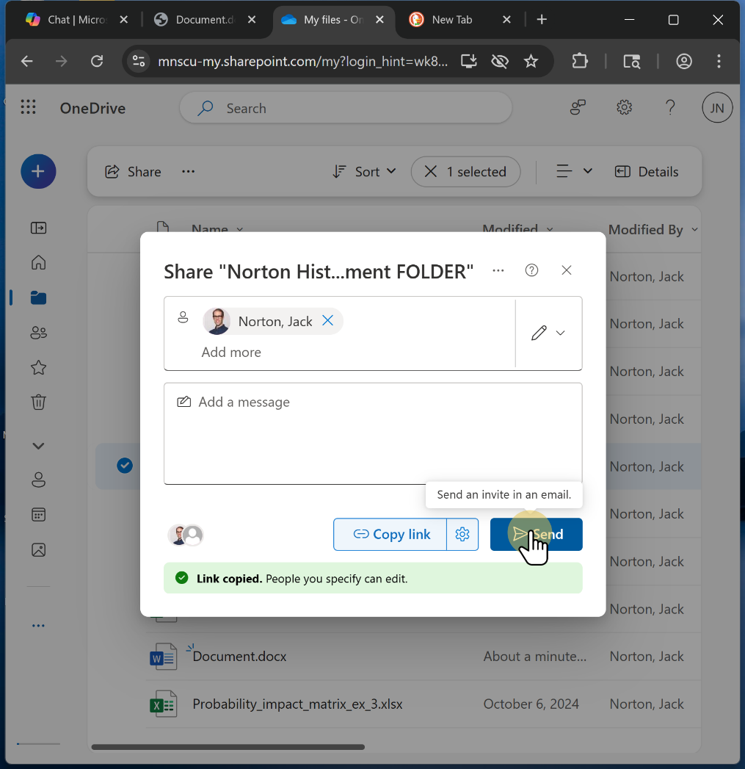

2.13. Click "September 12, 2024"

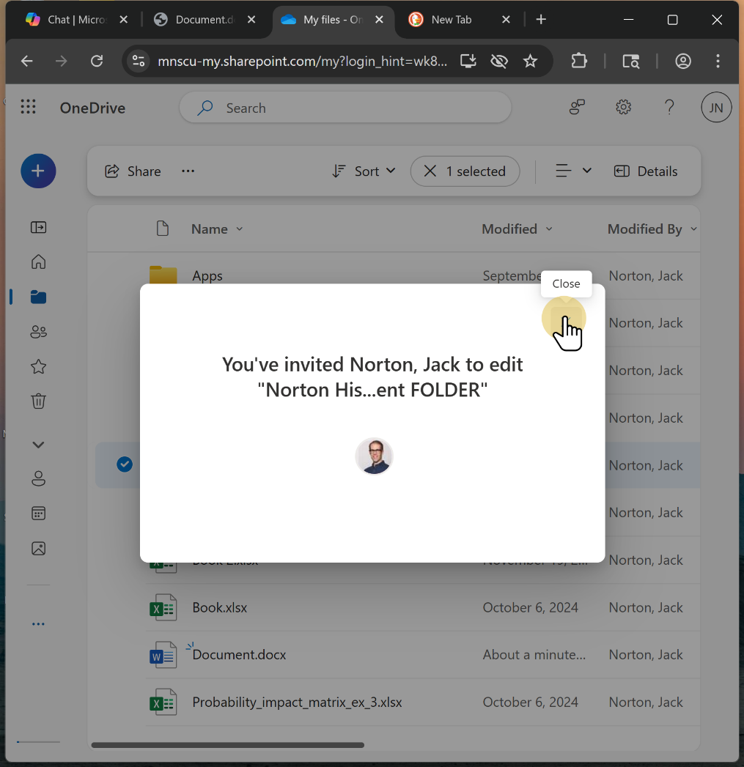

2.14. Post your shared FOLDER link in the Get to Know You form for our course.
Get to Know Your Form [https://docs.google.com/forms/d/e/1FAIpQLScLoWpOD_jDtv7XbgmpkNP-0zQCflmojetLm1AzRhHZtbumeQ/viewform?usp=dialog]
You may wish to leave this form open so you can post your Shared assignment FILE when you create it (the next steps).

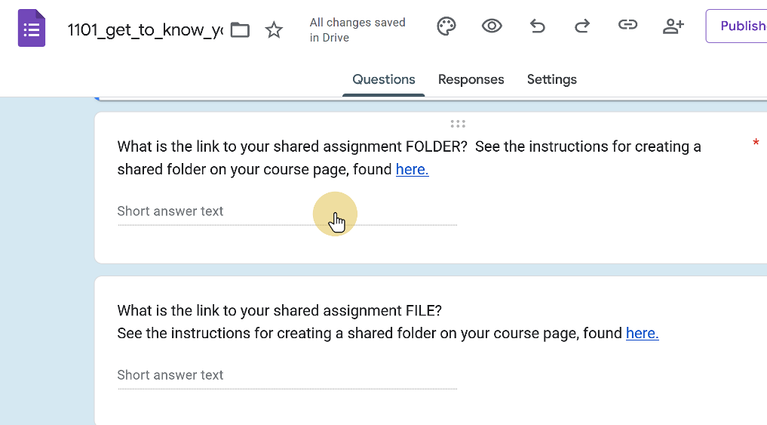

3. Return to the App launch page by clicking this icon.
Then open Word.

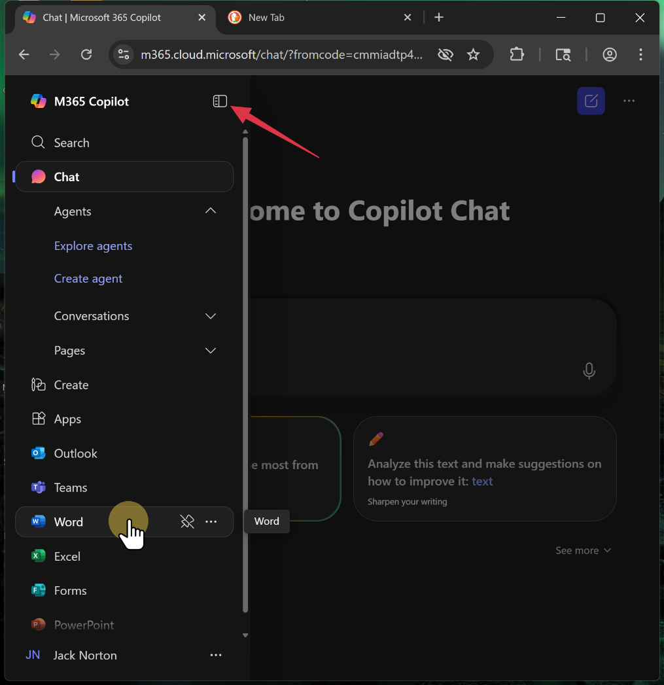

4. Sign in again (if necessary)

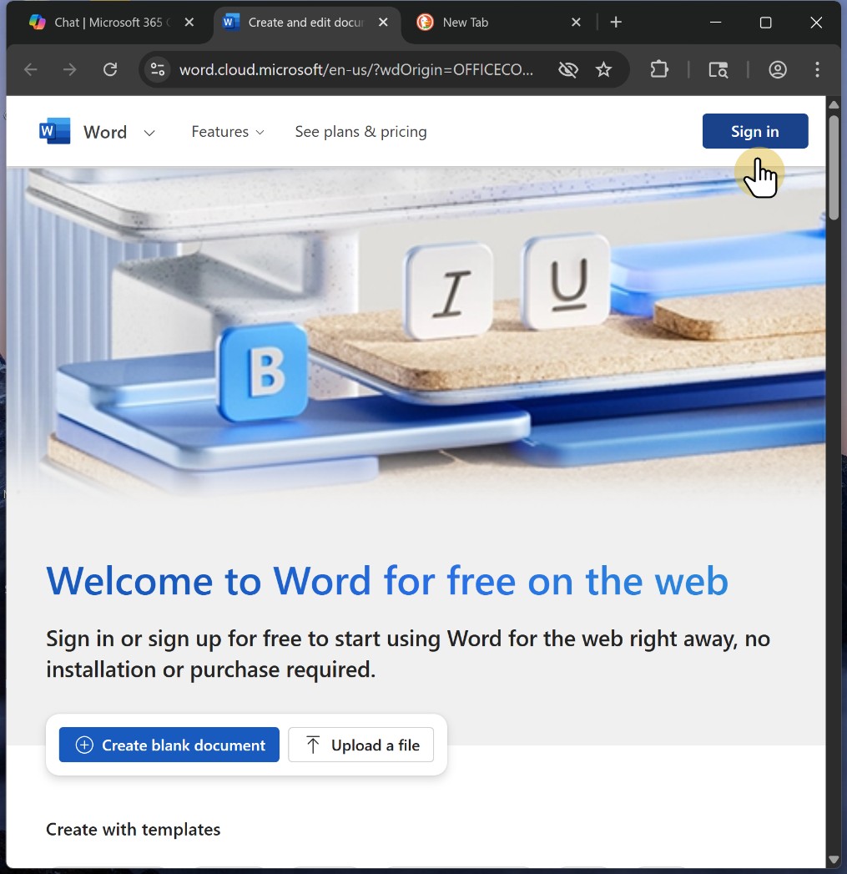

5. Create a blank document.

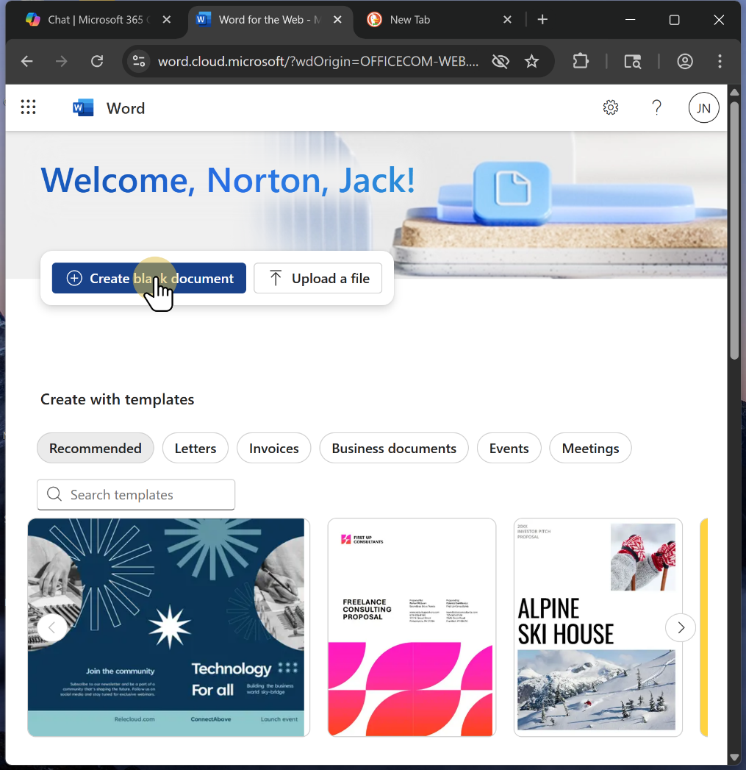

6. Allow access.

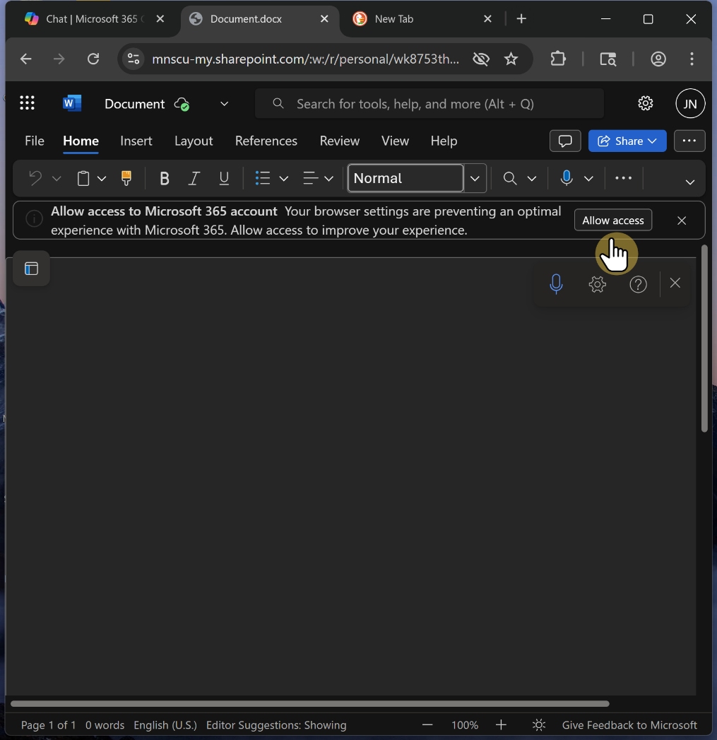

7. Click on the down arrow to give your file a name.
Save your FILE in your shared FOLDER

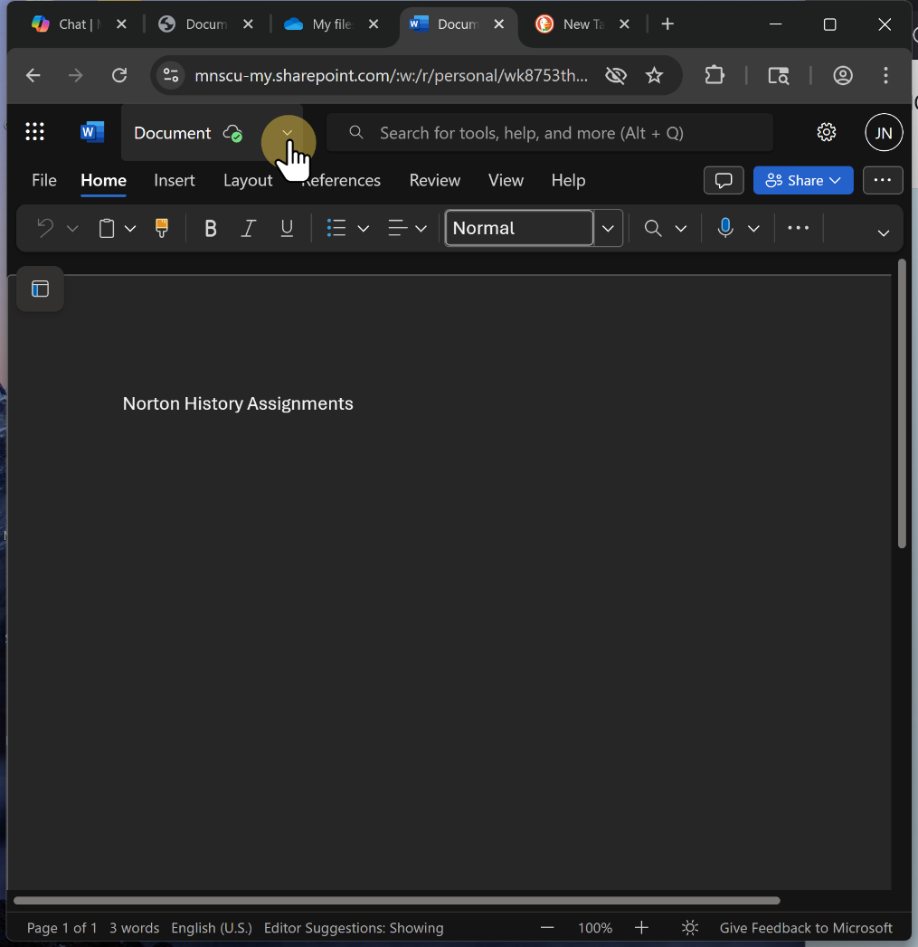

8. Name your filder last name_assignment_FILE and save in your assignment FOLDER

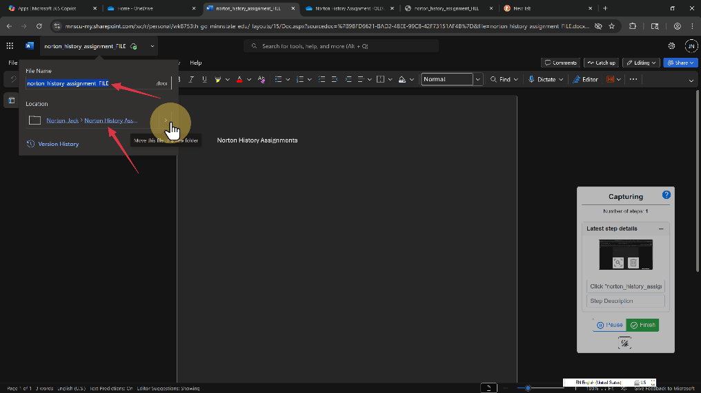

9. It may ask you to move the file to your History assignment FOLDER.
Do that

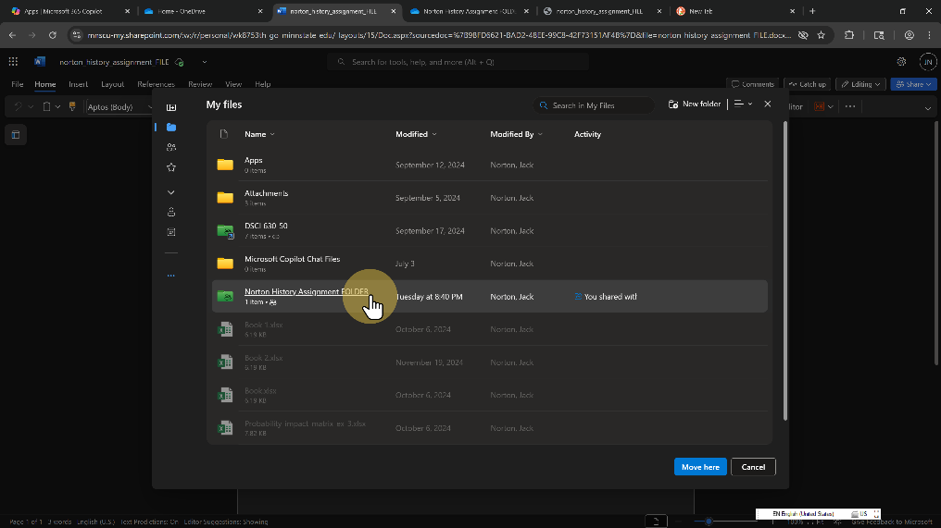

10. Share you file.

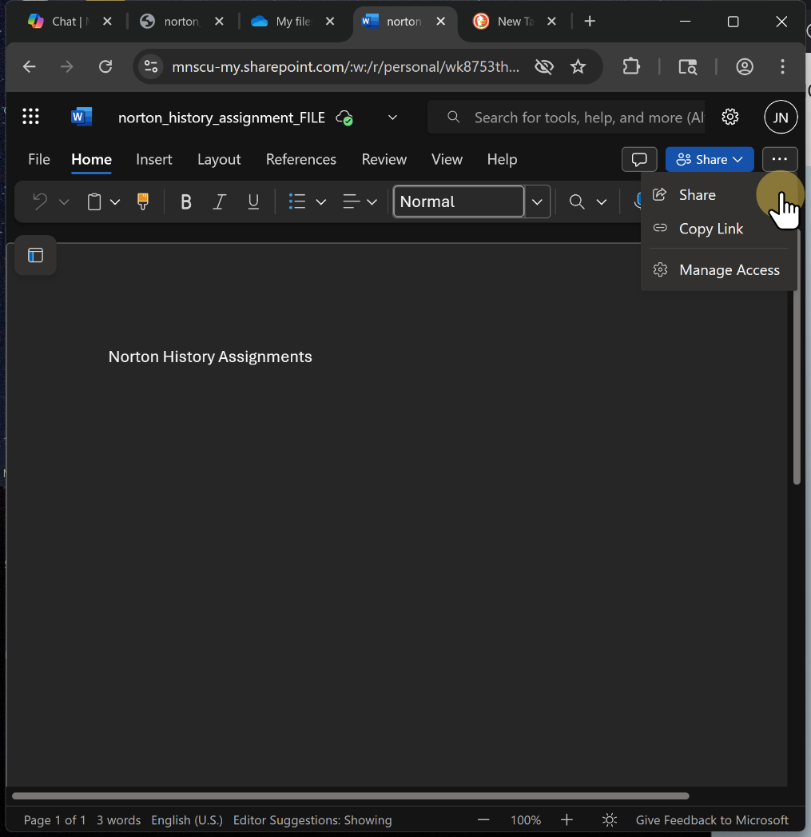

11. type in jack.norton@normandale.edu and select me to share.

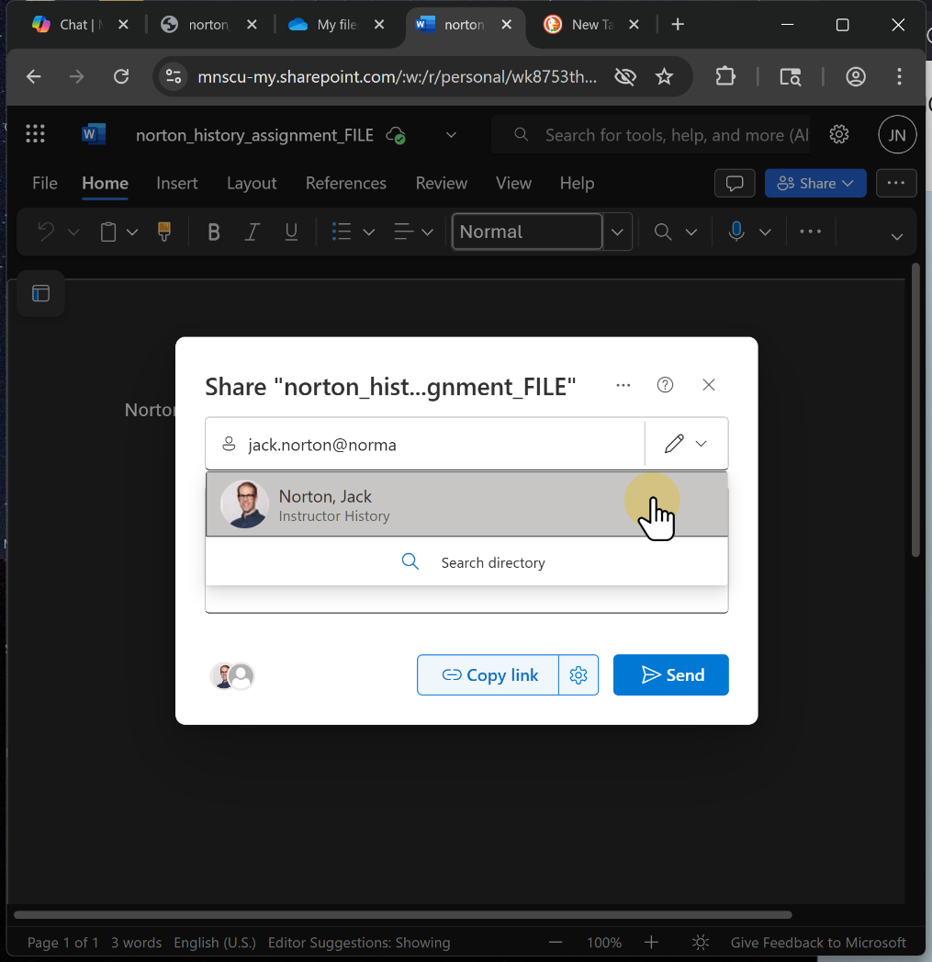

12. Add a message as you wish.

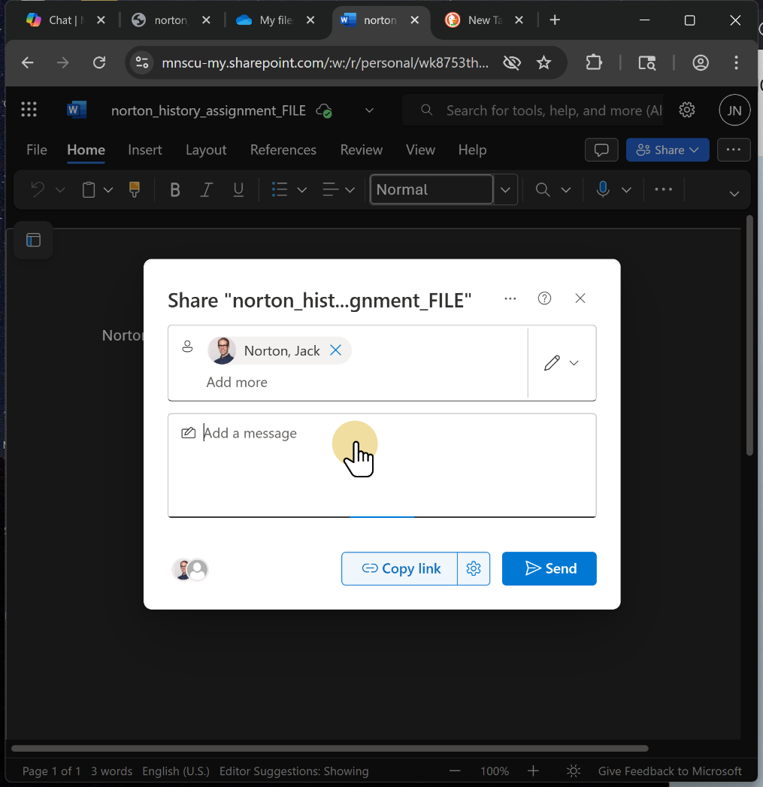

13. Copy the link BEFORE you send.

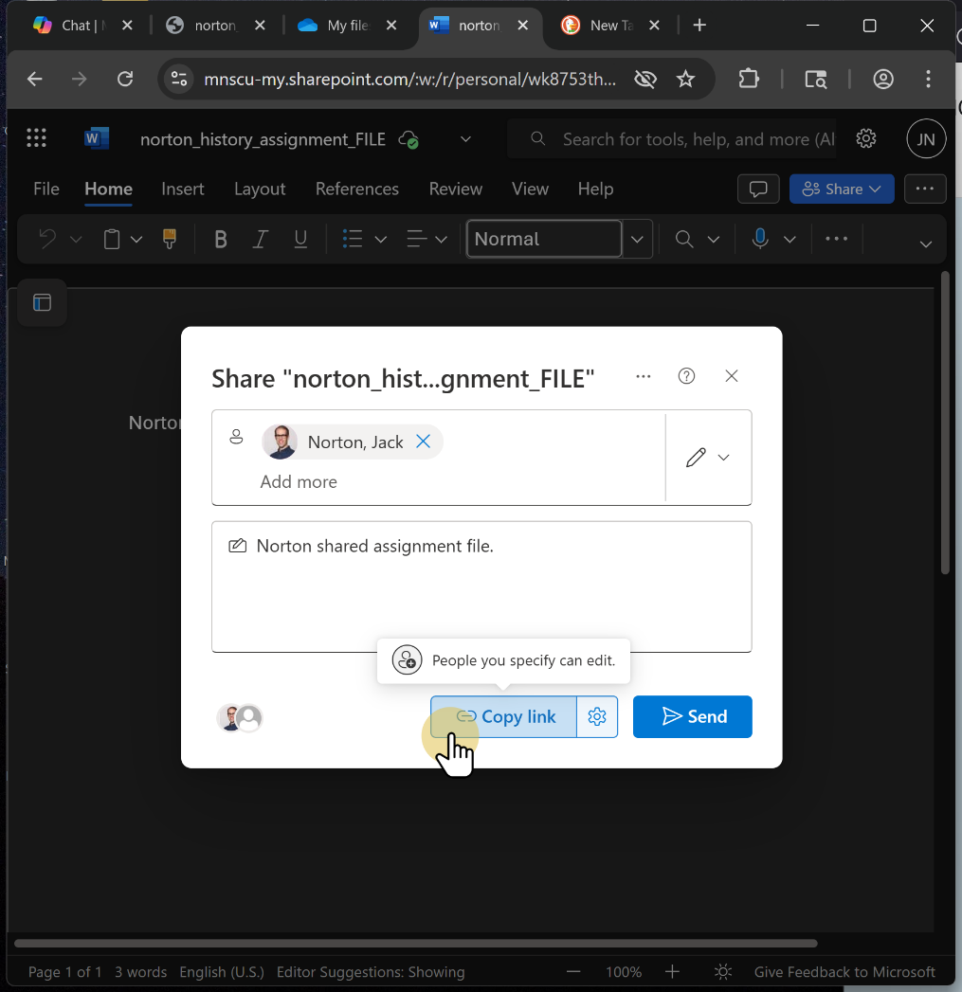

14. Click Send

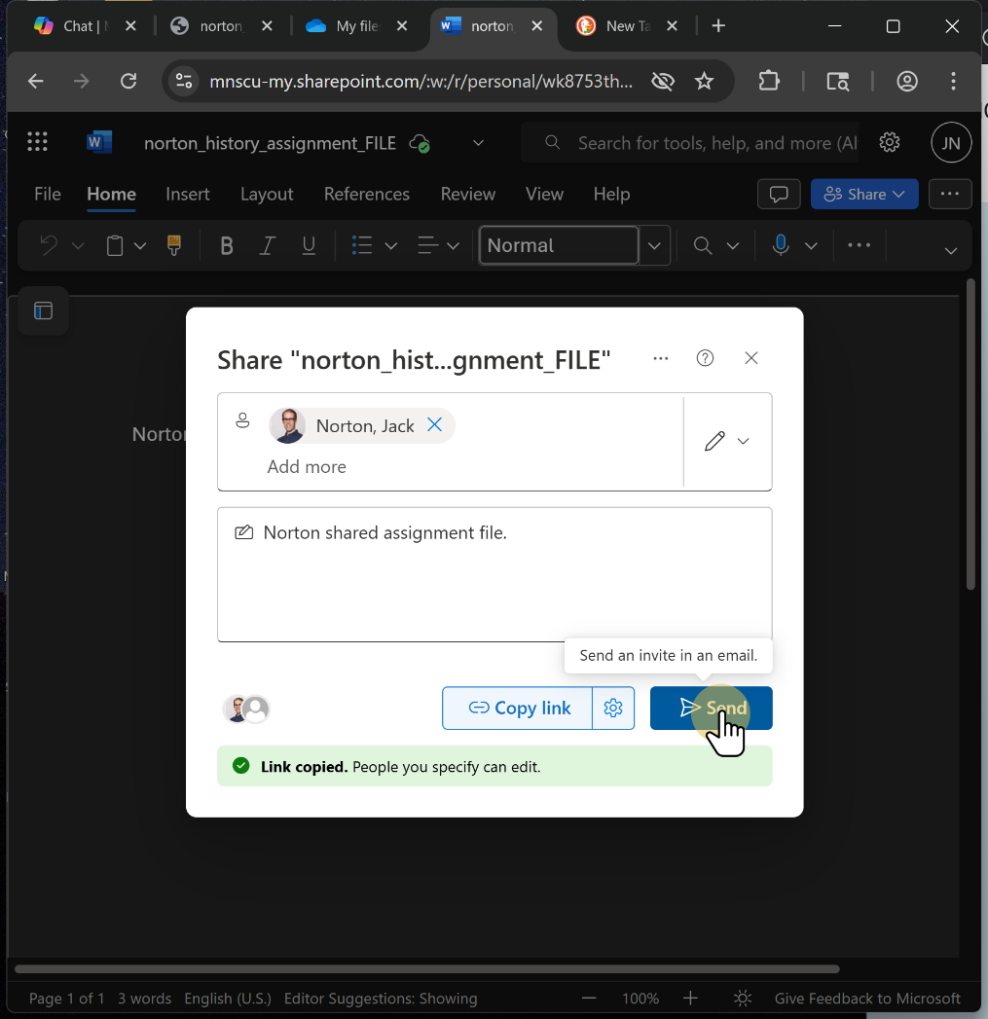

15. Click ""norton_his...nment_FILE""

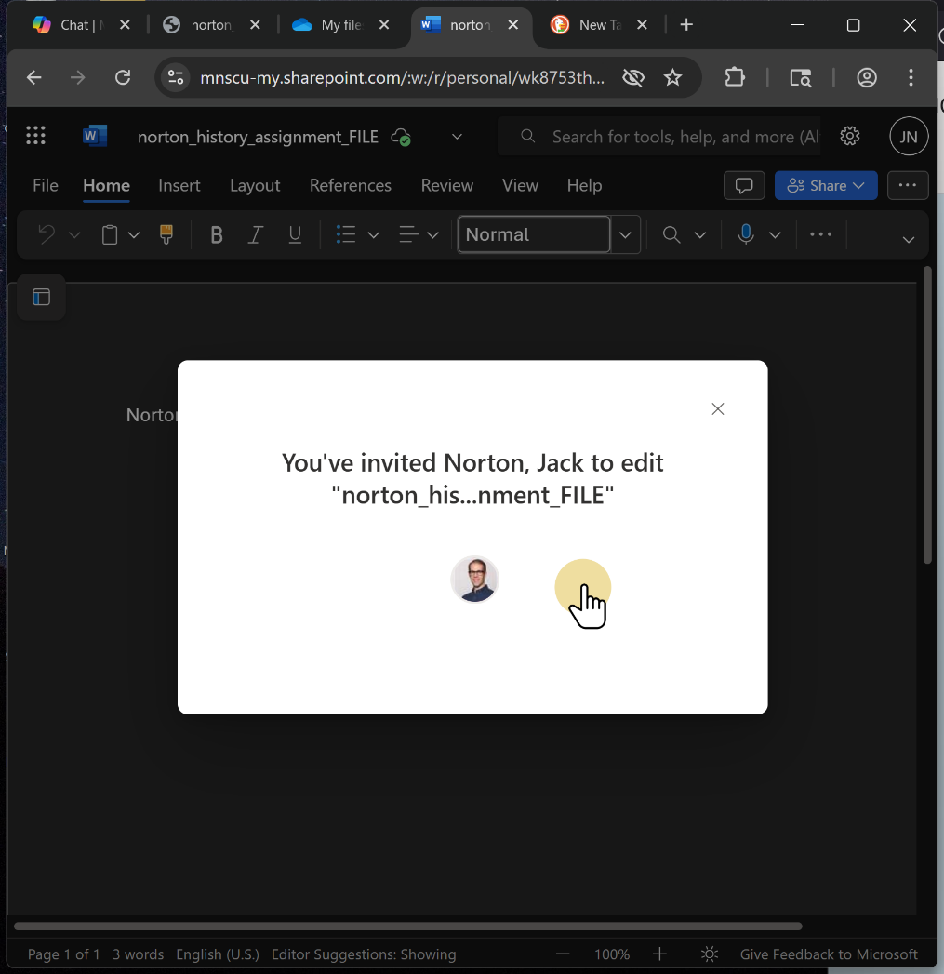

16. Paste your shared assignment FILE link in the Get to Know you Form.
Get to Know you Form. [https://docs.google.com/forms/d/e/1FAIpQLScLoWpOD_jDtv7XbgmpkNP-0zQCflmojetLm1AzRhHZtbumeQ/viewform?usp=dialog]

