ITS Service Desk:
952-358-8181

ZOOM TRAINING GUIDE for Students

INTRODUCTION TO ZOOM:
Zoom is a popular web conferencing tool. It can be used for a variety meeting types including meetings with 2 or more people, or webinar settings with larger groups.
- Zoom is a cloud-based conferencing solution that provides both video conferencing and screen share capabilities.
- Please keep in mind that Zoom is a cloud-based service, so no Internet Connection = No Zoom.

HOW TO JOIN AND LEAVE A MEETING:
- To join a meeting, simply click on the link provided by the host.
- (The meeting will open once the host has joined the room.)
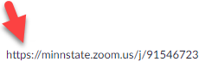
- You can leave your meeting room by clicking on the “Leave Meeting” icon in the bottom right-hand corner, or top of smartphone screen.

THE ZOOM MENU BAR :
When you join a Zoom room, the menu bar will be at the bottom of your screen.
- Hover your mouse near the bottom (or tap the screen) and the Zoom Menu Bar will appear.
- Below is a description of the items on the menu bar.
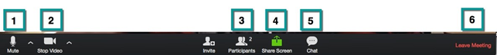
- Mute/unmute audio
- Stop/start video
- View a list of participants in the room. This will also allow you to see if anyone raised their hand if they have questions.
- Screen share your desktop or specific application window.
- Conduct a group or private chat.
- Leave the video meeting (Note: the “Leave” icon may appear at the top-right corner on a smartphone)

HOW TO UNMUTE AND MUTE YOUR AUDIO:
Select the microphone in the lower left-hand corner of the screen to activate your microphone. Select the icon again to mute.
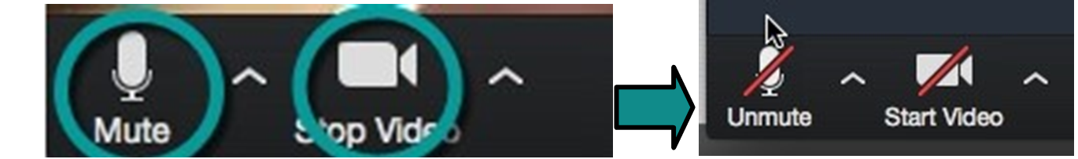
Audio is not muted Audio is muted

HOW TO START AND STOP YOUR CAMERA:
Select the camera in the lower left-hand corner of the screen to activate your video. Select the icon again to turn stop your video.
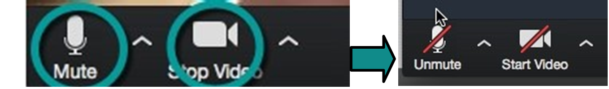
Camera is on Camera is off

SCREEN SHARE:
During a virtual meeting, you can switch back and forth between screen share and video as often as needed.
To share your screen you will select the “Share Screen” icon. Then click on the item you want to display, and then click “OK.”
- Once you share, the Zoom Menu Bar will be at the top of your screen.
- Again, you can hover your mouse near the top (or tap your screen) so that the Zoom Menu Bar will appear.

“Share” options on a desktop:
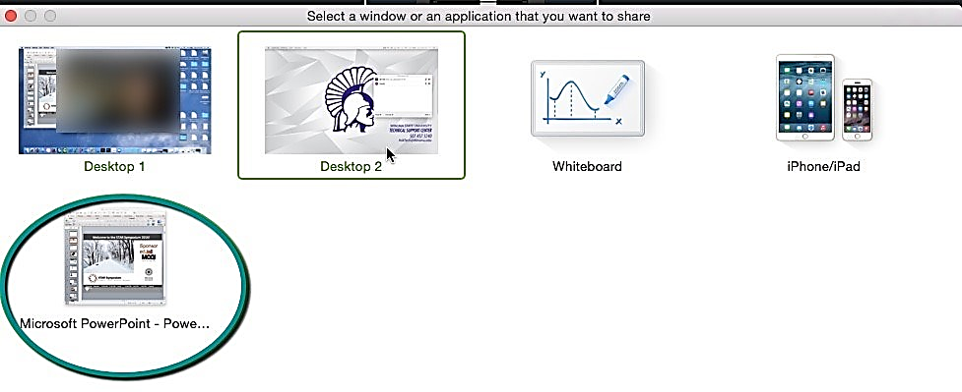

“Share” options on a smartphone:
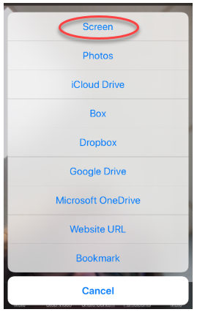

CHAT & PARTICIPANT ICONS:
Participants can also “raise their hand” which you can view on the Participant Feature.
- This is a great way to ask a question.
- You can also use the Chat feature to chat with the entire room or an individual.
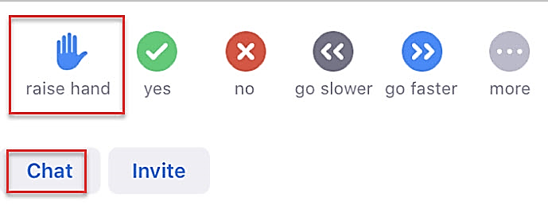

HOW TO HOST YOUR OWN MEETING:
From a desktop computer:
- Open a browser and go to https://minnstate.zoom.us/
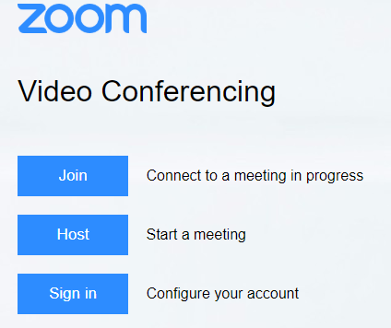

- Click “Host” – Use your Star ID & Password
- Select the settings you want to use for your meeting
- Share the meeting link ULR, or use the “Send invitation” or “Invite” icons to invite others to join the meeting.
From a smartphone:
- Download & open the Zoom app
- Click “Sign in”
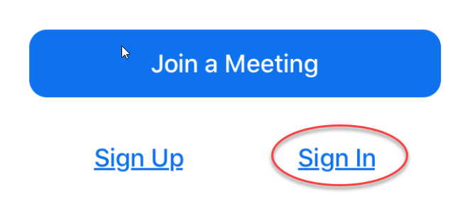
- Select “SSO” (which stands for “Single Sign-On”)
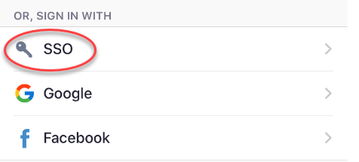
- Type “minnstate” in the company domain field
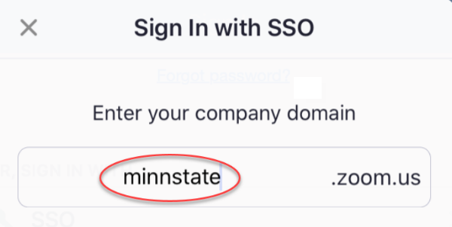
- Type your Star ID & Password, and click “Sign on”
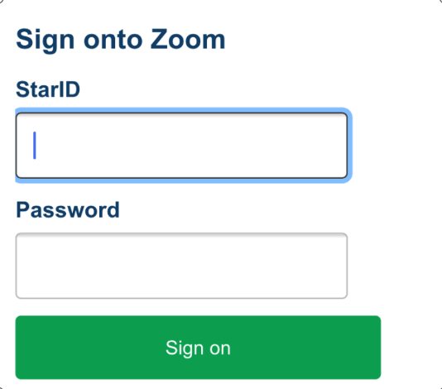
- Select “New meeting”
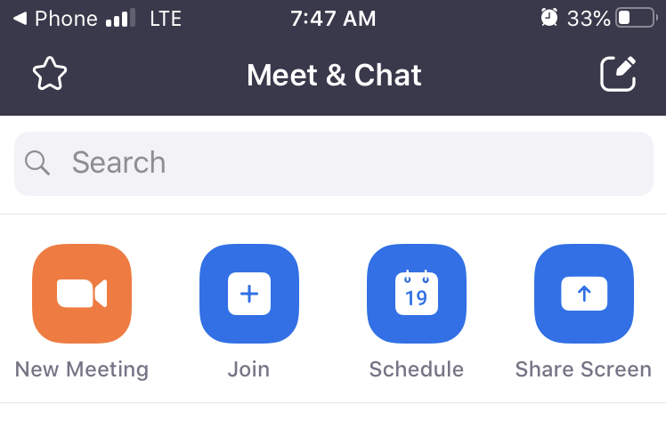
- Use the “Send invitation” or “Invite” icons to invite others to join the meeting.
- For a video tutorial, go to: https://youtu.be/ZAYv8sVPTxU

PROFESSIONAL TIPS FOR VIRTUAL ROOMS

ENVIRONMENT TIPS:
It’s important to keep in mind that even though this is a virtual webinar your location and surroundings are important. Here are some basic things to remember to create a professional virtual environment.
• Background – Check the background and rid the space of any clutter or distractions. You also want to make sure you are not positioned in front of a window as this can cause you to appear like a shadow. Keep your background simple.
• Noise – Is there background noise that could prevent participants from hearing clearly? It is recommended to conduct the webinar in an office or quiet room. Make sure to shut the door and hang a sign stating you are in a virtual webinar asking people not to enter or knock on the door. Also keeping your mic muted when you are not talking can help cut down on excess noise.
• Lighting – Double check the lighting when you launch the meeting and the video has started. Make sure more light is on your face than coming from behind you. You might also need to adjust where you are sitting so the light is not right above your head and within the camera framing.
• Framing – As an additional consideration be aware of your distance from the camera (not too close, not too far). You want to try and have the camera at eye level.

POSTURE AND BODY LANGUAGE TIPS:
• Sit up/don’t slouch – This helps you look engaged and confident.
• Smile – It’s easy to forget to smile, but it’s important to maintain a welcoming, positive interview, especially during when you are being introduced.
• Hand gestures –It’s OK to “talk with your hands” but try not to bring them too close to your camera. This can make your hands appear very large.

APPEARANCE TIPS:
Maintain a professional appearance on camera as you would in a face-to-face meeting. Dress professionally including solid colors. Stripes and busy patterned shirts can be a little overwhelming on camera.

